**LAPORAN PRAKTIKUM**

**PEMROGRAMAN WEB LANJUT**

**S1-SISTEM INFORMASI**

**“ LAPORAN PRAKTIKUM MODUL 5”**



**Disusun Oleh :**

|  |  |
| --- | --- |
| **Nama** | **Teuku Irvan** |
| **NIM** | **24.62.0219** |
| **Dosen Pengampu** | **Deni Kurnianto Nugroho** |
| **Nama Koordinator Asisten** | **Latif Ardiansyah** |
| **Kelas** | **BCIS** |

**S1 – SISTEM INFORMASI**

**FAKULTAS ILMU KOMPUTER**

**UNIVERSITAS AMIKOM YOGYAKARTA**

**2025**

# <<MODUL 5>>

## <<DATABASE , SESSION , COOKIE>>

### Tujuan

a. Explaining the understanding of database usage in web applications

b. Explaining the understanding of database connection functions

c. Explaining understanding MySQL with phpmyAdmin

d. Designing a simple database

e. Create a connection file

f. Explaining the understanding of the use of sessions and cookies

### Peralatan

### a. Desktop PC

### b. Windows 8 / 10

### c. Sublime. Source material: Sublime Text link - Text Editing, Done Right

### d. XAMPP. Source material: link Download XAMPP (apachefriends.org)\

### e. Web Browser

### C.

### Hasil dan Pembahasan

(isi dengan hasil dan pembahasan dari tugas anda, Pastikan screenshot jelas dan terbaca)

**COPY PASTE CODING TEMAN NILAI default = 3**

Anda boleh mengembangkan tampilannya, atau menambahkan identitas diri pada setiap file, namun inti dari script wajib tetap ada. Pastikan dijelaskan menggunakan Bahasa Indonesia yang baku dan sopan

The task in this practicum is to make a practicum report with the following provisions:

1. Practice Exercises 1 to Exercise 6

2. Screenshot of the database/ user table structure and news that have been created in

PHPMyAdmin as well as screenshots of the data in each table.

Database :

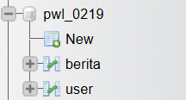

Table:

-Berita

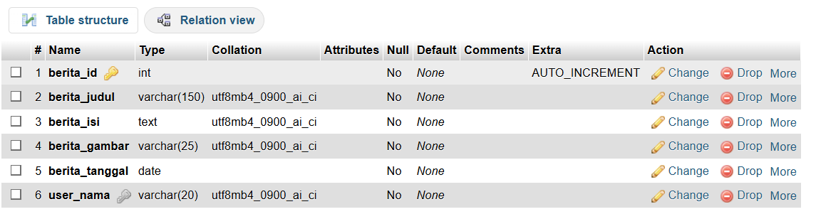

-User :

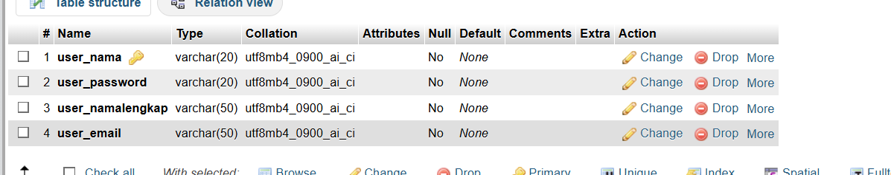

Isi data :

-Berita :



-User

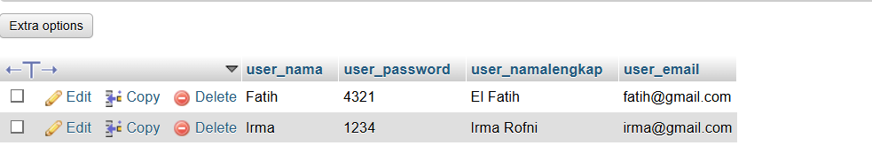

3. Screenshot your config.php script.

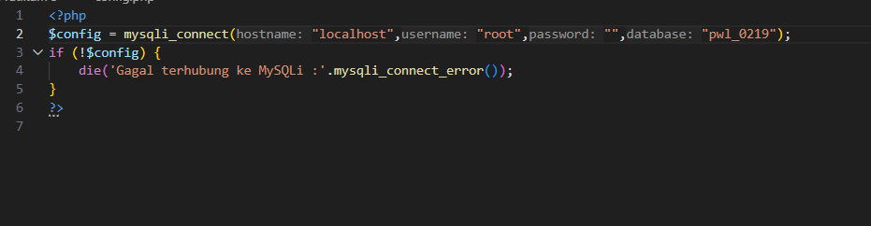

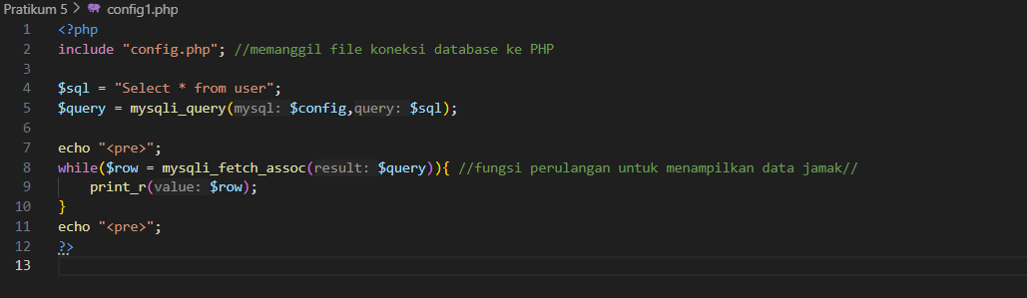

4. test results , starting from the login form display, successful and failed username and

password input.

Test Result :

* Login session :

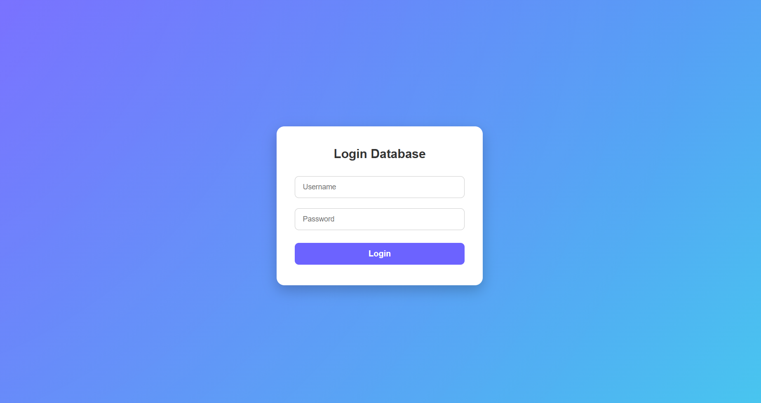

* Succes Login :
* 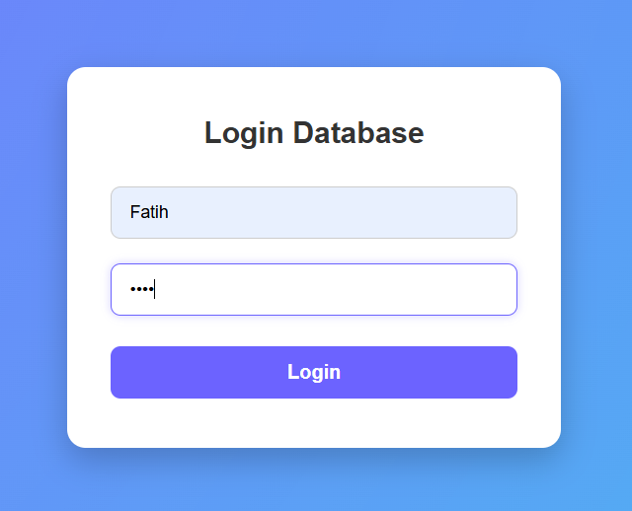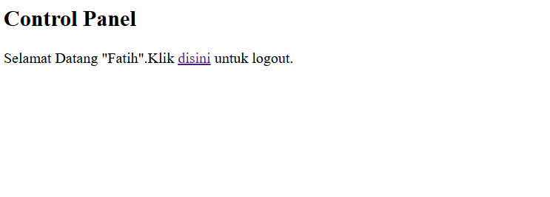

5. Screenshot of your welcome screen.

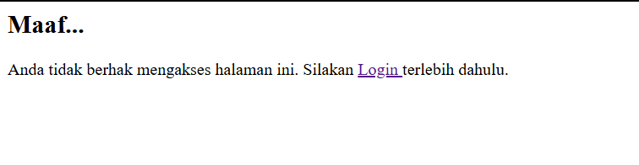

6. Did you successfully log out? Yes / No

- Yes , Logout Script :

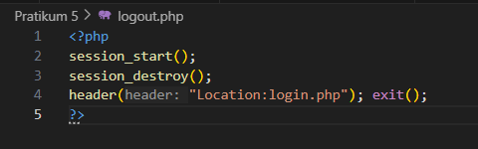

7. You may develop the appearance, or add your own identity to each file, but the core of the

script must remain.

### Eror /Kesulitan

(Point ini tidak wajib diisi. Point ini digunakan untuk menuliskan eror yang ada alami atau kesulitan selama praktikum dan cara mengatasinya. Pastikan dijelaskan menggunakan Bahasa Indonesia yang baku dan sopan)

### Daftar Pustaka

### [1] Arief, M. Rudyanto . (2011). Dynamic Web Programming Using PHP and MySQL.

### Andi Publisher : Yogyakarta

### Supporters:

### [2] Madcoms Madiun ( 2016). PHP and MySQL Programming for Beginners. Publisher

### Andi: Yogyakarta

### [3] PHP 5 Online Tutorial - http://www.w3schools.com/php

### [4] Arifin, Oki. ( 2017) . Advanced Web Programming Module. Yogyakarta: AMIKOM

### University Yogyakarta.

### [5] Advanced Web Programming Module . Yogyakarta: AMIKOM University

### Yogyakarta.